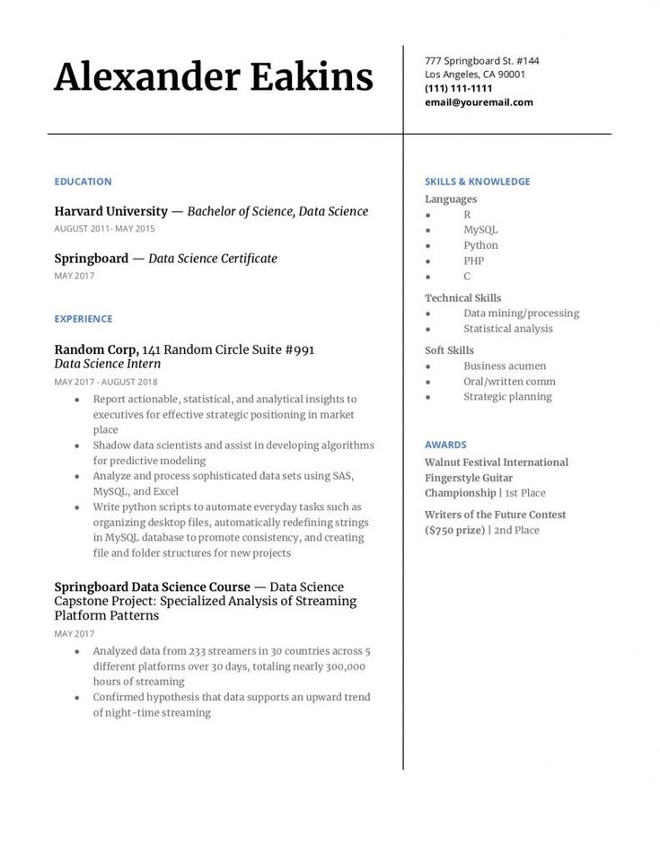
Alexander Eakins
777 Springboard St. #144 Los Angeles, CA 90001 (111) 111-1111 email@youremail.com
EDUCATION
Harvard University - Bachelor of Science, Data Science
AUGUST 2011-MAY 2015
Springboard - Data Science Certificate
MAY 2017
SKILLS & KNOWLEDGE
Languages
R
MySQL
Python
PHP
C
Technical Skills
Data mining/processing
EXPERIENCE
Random Corp, 141 Random Circle Suite #991 Data Science Intern
MAY 2017 AUGUST 2018
⚫
Report actionable, statistical, and analytical insights to executives for effective strategic positioning in market place
⚫ Shadow data scientists and assist in developing algorithms for predictive modeling
• Analyze and process sophisticated data sets using SAS, MySQL, and Excel
⚫ Write python scripts to automate everyday tasks such as organizing desktop files, automatically redefining strings in MySQL database to promote consistency, and creating file and folder structures for new projects
Springboard Data Science Course - Data Science Capstone Project: Specialized Analysis of Streaming Platform Patterns
MAY 2017
• Analyzed data from 233 streamers in 30 countries across 5 different platforms over 30 days, totaling nearly 300,000 hours of streaming
• Confirmed hypothesis that data supports an upward trend of night-time streaming
Statistical analysis
Soft Skills
Business acumen
AWARDS
Oral/written comm Strategic planning
Walnut Festival International Fingerstyle Guitar Championship | 1st Place
Writers of the Future Contest ($750 prize) | 2nd Place

